Instructions for Authors

The main objective of the Australasian Road Safety Conference (ARSC) is to compile and share current knowledge about the injury prevention countermeasures work in road safety. We invite research or practitioner/policy focused work that demonstrates strong evidence of an effective impact on reducing road trauma. Details for preparing your submission are provided below.

Please use this document to prepare your ARSC submission for the following presentation formats:
- Long oral presentation (15 mins)
- Short oral presentation (7 mins)
- Poster presentation with speed oral presentation (3 mins)
File name
- Name your file the first six words of the title. Do not include your name in the file name
Formatting
- The following pages are in the correct format for your submission
Delete this page before submitting
- Please only use the fonts, font sizes and spaces specified in this template
Word and page limits
- Some sections have a word limit, ensure you do not exceed these limits
- The limit for the total submission is 3 pages regardless of the total words
  - This includes references, figures, tables, etc.
Do not include any author names or affiliations on your submission
- All peer-reviews will be double-anonymised
  - Previously, reviewers knew the author names and affiliations
  - Research shows knowing authors names can introduce an unconscious bias. Reviewers may be influenced, positively or negatively, by the status, reputation or personal relationship with the author/s (Gilbert, 2023)
  - Blocking authors names allows reviewers to focus on the quality of the submission
- What do you do differently?
  - Do not include your name or the names of co-authors, on this submission
  - You will enter this information when you upload your submission
Social Media post
- All authors need to provide a short, one line description of the work in the format of a tweet
- This will be used to provide a short description in the conference app
- Some tweets may be used to promote the conference
- External use of the tweet via social media is optional
- You can opt-out of the tweet being used publicly when you upload your submission
After submission
- All submissions will be screened by the Scientific Committee to ensure each submission:
- reports on completed work that directly identifies a road safety benefit
- correctly uses the template including word and page limits
  - submissions that do not meet these criteria may be returned to the author for revision or rejected without further review
- The full submission review process is illustrated in Figure 1.

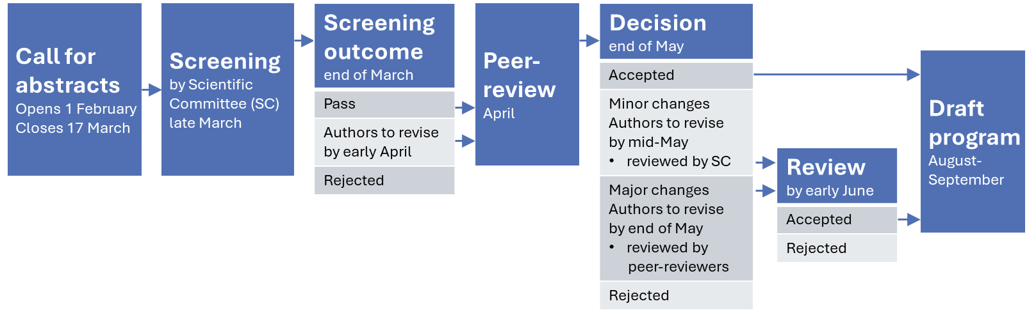
Figure 1. Timeline for submissions to ARSC2024

Reference
Gilbert, N., 2023. Anonymizing peer review makes the process more just. Nature. https://www.nature.com/articles/d41586-023-01772-w

Title of extended abstract (limit: 10 words)

Do not include any author names or affiliations.
You will enter these details when you upload your submission.

Abstract (limit: 150 words)
This template is for authors to use when preparing to submit an Extended Abstract to the Australasian Road Safety Conference (ARSC). Use this Abstract section to provide a short summary of the work including: the road safety issue that was addressed and why the work was needed; a brief overview of how the work was done; key results; main conclusions and, if applicable, potential translation into policy or practice. This Abstract is strictly limited to 150 words and will be used in the conference app to provide delegates with the information about what they can expect from the presentation of the work. Do not include references to publications in this section.

Post on X (limit: 280 characters)
Please write a one line description of your work in the format of a post (formerly a tweet on Twitter).
This is a requirement for submission but you can opt out of it being used publicly when you upload your submission.

Introduction OR Background
Use this section to explain the reasons why this work was important and include references to relevant publications (e.g. scientific research, published reports, websites, public policy). Only include published references that are publicly available. Do not include references to unpublished works that cannot be accessed by reviewers/readers.

The remaining sections can vary depending on the type of work you are presenting. Table 1 shows the options typically used and is also the format example of a table, table header, and table heading.

Table 1. Extended Abstract section heading options for submissions by sector (include above the table)
Section purpose | Sector
 | Practitioners | Researchers
Summary overview of work | Abstract | Abstract
Post (Tweet), one line description of work | Post | Post
Establish the road safety concern and research | Introduction  Background | Introduction
Details of the work that was completed | Project description  Overview  Approach | Method
Outcome of the work | Results  Findings  Evaluation and effectiveness | Results
Benefits to road safety | Benefits to road safety | Benefits to road safety
Implications for policy and/or practice | Implications for policy and/or practice | Implications for policy and/or practice
Conclusions | Conclusions | Conclusions
References | References | References

Second level header if required
When you upload your Extended Abstract, you will be asked if you are interested in expanding your Extended Abstract into a full paper for consideration for publication in the Journal of Road Safety. The decision of whether an Extended Abstract should be expanded will be made by the peer-reviewers based on the merit of your submission and the strength of the evidence-based contribution.

Authors whose Extended Abstracts are recommended for a full paper will be advised as part of the Decision following the peer-review. The full paper submission process is separate to the ARSC. Authors will be invited to submit their full paper for peer-review to the Journal of Road Safety to undergo peer-review by subject matter experts.

Third level header if required
The conference theme this year is ‘Target 2030: What’s the pathway forward?’. All submissions to the ARSC should explicitly address this theme. All presentations including posters will be assessed for the Best Conference Theme Prize.

Systematic literature review
If you are presenting a systematic literature review, you need to include details of the protocol used (e.g. PRISMA or MOOSE etc.). This will be checked in the Screening stage and is required to progress to the full peer-review.

No advertising
Businesses with products or programs with road safety applications are encouraged to join the conference as part of the Exhibition. However, we are not able to accept promotional material as part of the main program.

During the screening stage, the Scientific Committee will determine if submissions are an attempt to advertise a product or program without any supporting research or practice findings and may seek clarification from authors prior to progressing a submission to the peer review stage.

Third level header if required
Insertion of tables and figures are permitted. These can be as large as a whole page, portrait or landscape, or smaller tables and figures. The only restriction is that the total submission cannot be more than three (3) pages.

Figure 1. Include the description below the figure (image example only)
Source: Australasian College of Road Safety (reproduced with permission)

Copyright permission
It is your responsibility as the lead author to ensure you have permission to reuse or publish all content included in your Extended Abstract. This includes, but is not limited to:
- Photographs: ensure that you have permission to include any photographs including permission from any person whose face is identifiable, this includes parental permission if the image is of a child.
- Reproduction of any image (table, figure, chart etc.) that has been previously published

In-text citation
Use the APA style when citing work in your text and in the list of references. Examples are provided in Table 2.

Table 2. Examples of in-text citation using APA style
Number of authors | Example of how to cite in text
One author | Include the surname of the author with the date of the publication (Williamson, 2023).
Two authors | Name both authors every time you cite the work (Haworth & Lydon, 2020).
Three or more authors | Only include the first author every time you cite the work, followed by the letters and punctuation et al., then the year of publication (Charlton et al., 2024). The letters et al. translates from Latin as ‘the others’.

References (limit: 10 references)
- Include current publications to ensure the work represents the most current road safety knowledge
- References are limited to 10 per Extended Abstract
- Self-citation references are limited to 20 percent of all references listed
- Use the APA style formatting
- List in alphabetical order
- Use a 1cm hanging indent, examples are given below

Ashish, & Mhaske, S. Y. (2023). Road Safety Audit (RSA) guidelines of selected nations – a comparative review. Journal of Road Safety, 34(4), 42–50. https://doi.org/10.33492/JRS-D-23-209291
Gijre, V., & Ram, S. (2023). Spatial and Temporal Pattern of Bus Crashes in City Bus Transport: Case of Delhi Transport Corporation (DTC), India. Journal of Road Safety, 34(4), 11–19. https://doi.org/10.33492/JACRS-D-22-00025
Hidayat, E., Lange, D., Karlovsek, J., & Kim, J. (2023). Variables Affecting the Risk of Vehicle Collisions in Australian Road Tunnels. Journal of Road Safety, 34(4), 20–30. https://doi.org/10.33492/JACRS-D-22-00032
Johnson, M., Napper, R., Johnston, V., & Corser, J. (2023). How to successfully engage a community in road safety. Journal of Road Safety, 34(4), 31–41. https://doi.org/10.33492/JACRS-D-22-00050
Roberts, P. L., & Meuleners, L. B. (2023). Optimising Alcohol Interlock Program Performance. Journal of Road Safety, 34(4), 51–60. https://doi.org/10.33492/JACRS-D-21-00042
Zenu, S., Tesfaye, A., Roba, G., & Negera, E. (2023). Factors in Road Traffic Crashes Among Drivers in Buno Bedelle Zone, Southwest Ethiopia: A Case Control Study. Journal of Road Safety, 34(4), 1–10. https://doi.org/10.33492/JACRS-D-22-00012

